SIR APOLLO KAGGWA SCHOOLS
MID TERM II – 2024
PRIMARY SEVEN
INTEGRATED SCIENCE
Time allowed: 2 hours 15 minutes

Name: ______________________________________________________________
School: _____________________________________________________________
FOR EXAMINER’S USE ONLY
Read the following instructions carefully:
- The paper has two sections: A and B
- Section A has 40 questions (40 marks)
FOR EXAMINER’S USE ONLY

Qn. No | MARK | SIGN
1 – 10
11 – 20
21 – 30
31 – 40
41 – 43
44 – 46
47 – 49
50 – 52
53 – 55
TOTAL

- Section B has 15 questions (60 marks)
- Answer ALL questions. All answers to both Sections A
and B must be written in the spaces provided.
- All answers must be written using a blue or black ball
point pen or ink. Diagrams should be drawn in pencil.
- Unnecessary crossing of work may lead to loss of marks.
- Any handwriting that cannot be easily read may lead to
loss of marks.
- Do not fill anything in the boxes indicated;
For Examiner’s use only.

Turn over

SECTION A (40 marks)
(Questions 1 to 40 carry one mark each)
1. Name the largest group of mammals in Uganda.
_______________________________________________________________________
_______________________________________________________________________
2. Name one cold blooded vertebrate that has a body shell.
_______________________________________________________________________
_______________________________________________________________________
3. Suggest one way in which water is important in our bodies. _______________________________________________________________________
_______________________________________________________________________
4. Which substance can exist in the three states of matter?
_______________________________________________________________________
_______________________________________________________________________
5. Which stage in the life cycle of a housefly is important to man?
_______________________________________________________________________
_______________________________________________________________________
6. Which part of the seed develops into a new plant?
_______________________________________________________________________
_______________________________________________________________________
7. Identify the part of a skeleton that protects the brain.
_______________________________________________________________________
_______________________________________________________________________
8. How does a gecko (lizard) help man in daily life?
_______________________________________________________________________
_______________________________________________________________________
9. Identify any one method of making magnets.
_______________________________________________________________________
_______________________________________________________________________
10. Where does fertilization take place in mammals?
_______________________________________________________________________
_______________________________________________________________________
11. Give one example of a bird with a chisel-shaped beak.
_______________________________________________________________________
_______________________________________________________________________
12. Why is a mushroom unable to make its own food?
_______________________________________________________________________
_______________________________________________________________________
13. Name the natural habitat of a rabbit.
_______________________________________________________________________
_______________________________________________________________________
14. Why do insects visit flowers?
_______________________________________________________________________
_______________________________________________________________________
15. Why are cockroaches considered to be vectors.
_______________________________________________________________________
_______________________________________________________________________
16. Why is distilled water not good for drinking?
_______________________________________________________________________
_______________________________________________________________________
17. Name the mineral salt found in iodised salt.
_______________________________________________________________________
_______________________________________________________________________
18. Of what importance is a blubber to a whale.
_______________________________________________________________________
_______________________________________________________________________
19. Why should living rooms be painted with light colours?
_______________________________________________________________________
_______________________________________________________________________
20. In the space below, draw and label the parts of a stamen.

21. How can one control echoes in cinema halls?
_____________________________________________________________________
_____________________________________________________________________
22. Paul uses a wheelbarrow to carry potatoes from his garden to the market. What is the advantage of using such a machine.
_____________________________________________________________________
_____________________________________________________________________
23. Name one product of petroleum.
_____________________________________________________________________
_____________________________________________________________________
24. How does the use of electricity to cook conserve the environment?
_____________________________________________________________________
_____________________________________________________________________
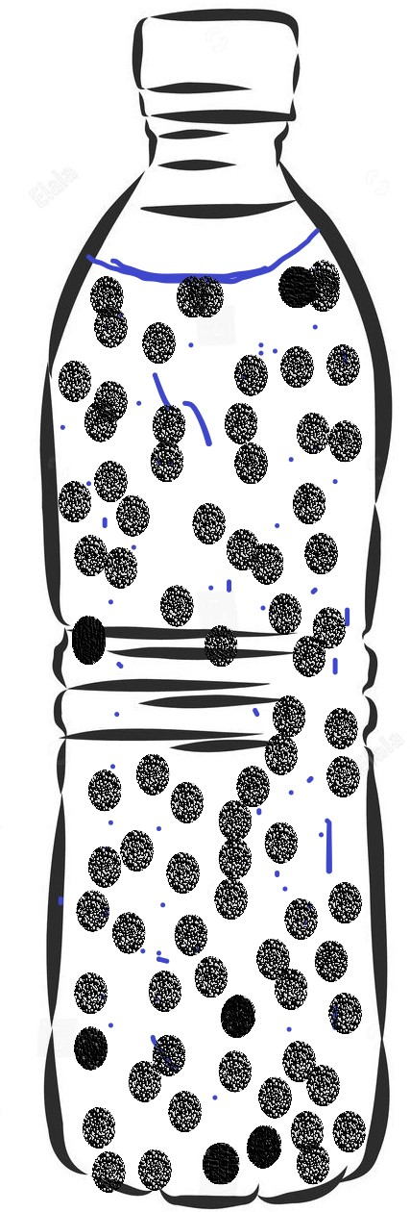
Use the diagrams below to answer question 25.
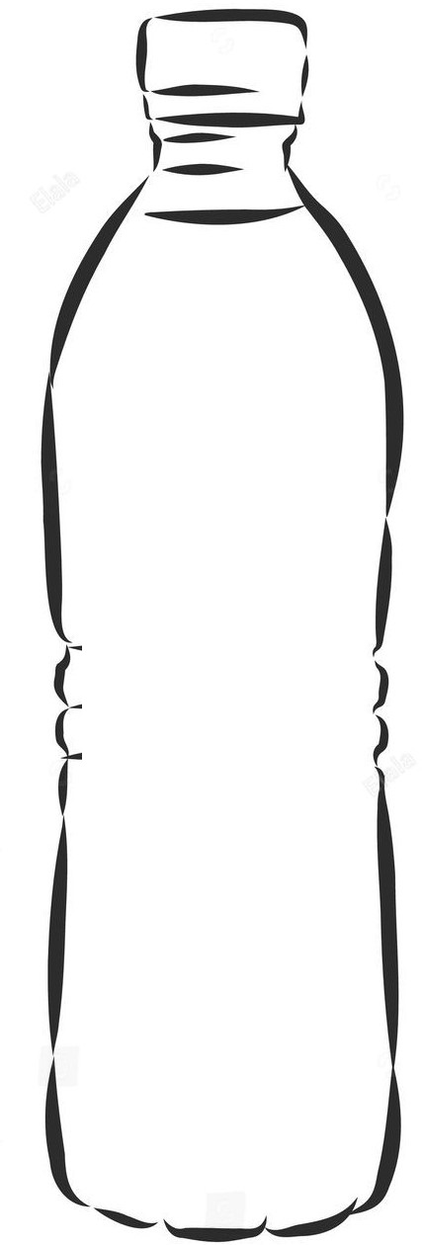

M N
25. Which bottle will produce the highest pitch of sound?
_____________________________________________________________________
_____________________________________________________________________
26. What type of reproduction does a frog undergo?
_____________________________________________________________________
_____________________________________________________________________
27. Convert 30⁰C to F.

28. Define a nursery bed.
_____________________________________________________________________
_____________________________________________________________________
29. What process will you use to recover salt which has dissolved in water?
_____________________________________________________________________
_____________________________________________________________________
30. Why has the government of Uganda banned smoking in public places?
_______________________________________________________________________
_______________________________________________________________________
31. Fish and birds have streamlined body shapes. Of what importance is this to the animals?
_______________________________________________________________________
_______________________________________________________________________
32. Name the form of energy stored in a dry cell.
_______________________________________________________________________
_______________________________________________________________________
33. In what way can a child get natural immunity?
_______________________________________________________________________
_______________________________________________________________________
34. How useful are the ligaments in the human body?
_______________________________________________________________________
_______________________________________________________________________
35. Mention the importance of a micropyle to a bean seed.
_______________________________________________________________________
_______________________________________________________________________
Below is a blood cell. Use it to answer questions 36 and 37.
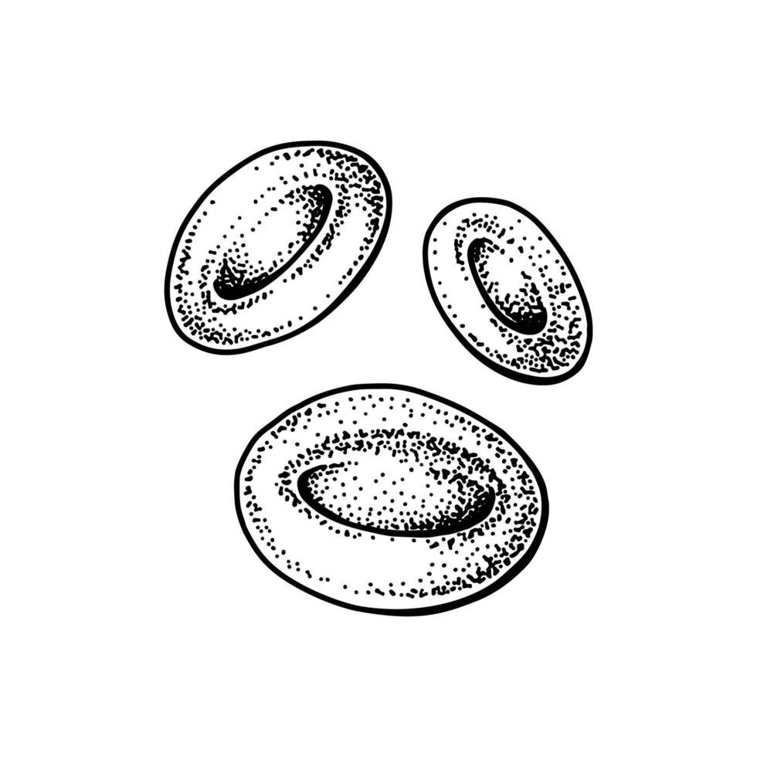

36. Name the blood cell shown above.
________________________________________________________________________
_______________________________________________________________________
37. What is the function of the blood cell you have named in No. 36 above?
________________________________________________________________________
_______________________________________________________________________
38. Mention one characteristic of arachnids.
_______________________________________________________________________
_______________________________________________________________________
39. Give one example of a drupe.
_____________________________________________________________________
_____________________________________________________________________
40. When do we use the displacement method?
________________________________________________________________________
________________________________________________________________________

SECTION B
41. Name the parts of the body where we find these joints;
(a) Ball and socket joint ________________________________________________
________________________________________________________________
(b) Hinge joint _______________________________________________________
________________________________________________________________
(c) Plane (Gliding) joint ________________________________________________
________________________________________________________________
(d) Pivot joint ________________________________________________________
________________________________________________________________
42. (a) Define the term “Frequency” in relation to sound energy.
________________________________________________________________
________________________________________________________________
(b) Mention two factors that determine the pitch of sound of a guitar.
(i) ________________________________________________________________
(ii) ________________________________________________________________
(c) Write down one way of storing sound.
________________________________________________________________
________________________________________________________________

43. Below is a diagram of an electric circuit. Use it to answer questions that follow.
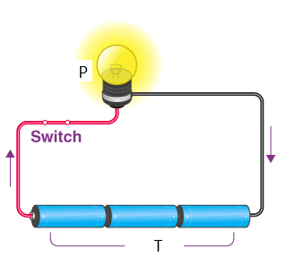

(a) Identify the parts labelled:
(i) P _______________________________________________________________
(ii) T _______________________________________________________________
44. (a) Which type of soil is suitable for agriculture?
________________________________________________________________
(b) Give a reason to support your answer in (a) above.
________________________________________________________________
________________________________________________________________
(c) Mention one way how soil is formed.
________________________________________________________________
________________________________________________________________
(d) Which component of soil helps in improving soil aeration?
________________________________________________________________
45. Match the following terms in A with their correct definitions in B
A B
(a) Incubation - A type of chicken kept for egg production.
(b) Brooding - Shortening of the upper part of the birds’ beak.
(c) Layers - Provision of favourable conditions to eggs to hatch.
(d) Debeaking - Care given to chicks from 1 day to 8 weeks.
(a) Incubation ______________________________________________________
(b) Brooding ______________________________________________________
(c) Layers ______________________________________________________
(d) Debeaking ______________________________________________________
46. (a) Explain the term “Family Planning”.
________________________________________________________________
________________________________________________________________
(b) Give one artificial permanent method of family planning.
________________________________________________________________
________________________________________________________________
(c) Suggest one reason why some parents have many children.
________________________________________________________________
________________________________________________________________
(d) Write one advantage of practicing family planning.
________________________________________________________________
________________________________________________________________
47. (a) By what process does a fish get oxygen from water?
________________________________________________________________
________________________________________________________________
(b) State the function of the parts of a fish below on its body.
(i) Lateral line _______________________________________________________ ________________________________________________________________
(ii) Nostril ___________________________________________________________
________________________________________________________________
(c) How are the eggs of a fish fertilized?
________________________________________________________________
________________________________________________________________
48. The diagram below shows a saucepan with some water on fire. Use it to answer the questions that follow.
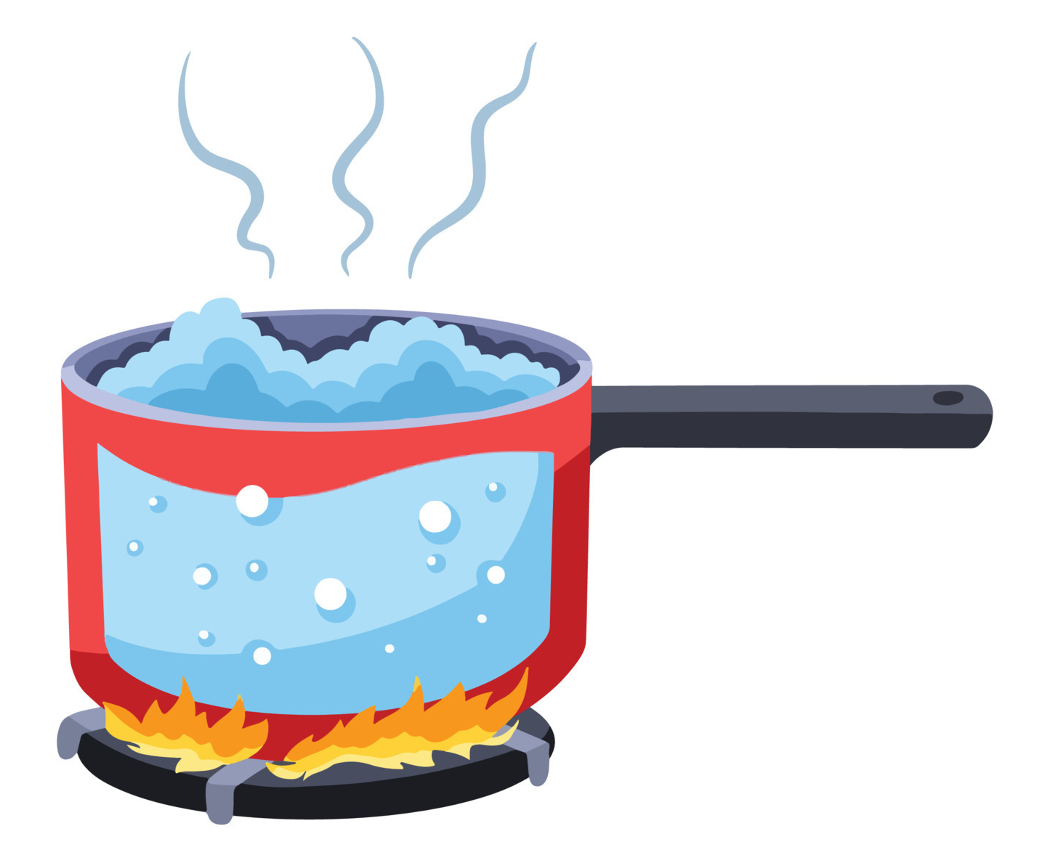
B

(a) Identify the type of change taking place at B.
________________________________________________________________
________________________________________________________________
(b) Give a reason to support your answer in (a) above.
________________________________________________________________
________________________________________________________________
(c) How will heat from the fire move to reach the water at the bottom of the saucepan.
________________________________________________________________
________________________________________________________________
(d) Use arrows to show the movement of water in the saucepan after it has been heated for some time.

49. (a) In which way is the sun useful to plant life?
________________________________________________________________
________________________________________________________________
- List down any two raw materials needed for photosynthesis to take place.
- ________________________________________________________________
- ________________________________________________________________
(c) Name the food manufactured by green plants during photosynthesis.
________________________________________________________________
________________________________________________________________
50. (a) What are poultry vices.
________________________________________________________________
________________________________________________________________
(b) How is litter from a deep litter system useful to a crop farmer?
________________________________________________________________
________________________________________________________________
(c) State any two disadvantages of free range system of poultry keeping.
(i) ________________________________________________________________
________________________________________________________________
(ii) ________________________________________________________________
________________________________________________________________
51. (a) What is a balanced diet? ________________________________________________________________
________________________________________________________________
(b) State the general word used to mean diseases caused by lack of a balanced diet.
________________________________________________________________
________________________________________________________________
(c) Give two reasons why people fail to have a balanced diet.
(i) ________________________________________________________________
________________________________________________________________
(ii) ________________________________________________________________
________________________________________________________________
52. (a) Suggest the blood component affected by;
(i) HIV ___________________________________________________________
(ii) Plasmodium _____________________________________________________
(b) How are bones related to blood?
________________________________________________________________
________________________________________________________________
(c) What advice would you give to someone whose baby has anaemia?
________________________________________________________________
________________________________________________________________
53. The diagram below shows bread mould.
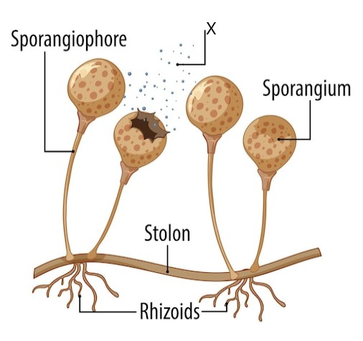

- What is found in part X?
________________________________________________________________
________________________________________________________________
(b) How do bread moulds reproduce?
________________________________________________________________
________________________________________________________________
(c) To which group of living things do they belong?
________________________________________________________________
(d) Give one use of such living organisms.
________________________________________________________________
________________________________________________________________
54. (a) What is pollination?
________________________________________________________________
________________________________________________________________
(b) Name the gametes in plants which are similar to sperms in animals.
________________________________________________________________
________________________________________________________________
(c) Which part of a flower develops into a fruit?
________________________________________________________________
________________________________________________________________
(d) Give one example of a berry.
________________________________________________________________
________________________________________________________________
55. (a) Give an example of each of the following groups of birds.
(i) Birds of prey: _____________________________________________________
(ii) Wading birds: _____________________________________________________
(b) Mention one advantage and one danger of birds to man.
(i) Advantage:
________________________________________________________________
________________________________________________________________
(ii) Danger:
________________________________________________________________
________________________________________________________________

Good luck
P.7 Science 2024

- Primates
- Turtle
- It makes digestion possible/Water dilutes toxins to make them less harmful/Water helps in absorption of food/maintains body shape/blood movement
- Water
- Larva
- Cranium/skull
- …..
- A gecko eats up harmful insects that fly in the house and those that crawl on the walls.
- Induction/stroking methods/Electrical method
- In the oviduct/In the fallopian tubes.
- The wood pecker
- …..because it lacks chlorophyll.
- Burrow
- To get/collect nectar.
- They spread germs that cause diseases.
- …because distilled water lacks mineral salts.
- Iodine
- It keeps the whale warm.
- To have enough light in the room/to regulate heat in the room.

- By putting soft wood boards on the walls/By putting thick carpets on the floor.
- He uses less effort.
- Petrol/Kerosene/Vaseline/Diesel/Plastic/ Polythene bags.
- It reduces the rate at which people cut down trees for wood fuel.
- Bottle N.
- Sexual reproduction.
- 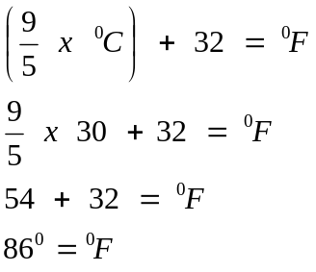
- Is a small garden where seeds are first planted before they are taken to the main garden as seedlings.
- Evaporation.
- To prevent the spreading of lung infections as a result of smoking.
- Streamlined body shaped help fish and birds overcome the force of viscosity.
- Chemical energy
- Through breast feeding/After suffering and recovering from an illness.
- Ligaments join bones to bones.
- It admits moisture and air into the seed during germination.
- Red blood cell.
- It transports oxygen in the body.
- They have two main body parts. They are wingless/They eight jointed legs.
- Mango/coconut/Avocado
- When finding the volume of objects with irregular shapes.
- –
- Shoulder/Hip (pelvic girdle)
- Knee/elbow
- Ankle/wrist
- neck
- –
- Frequency is the number of vibrations produced per second.
- The thickness of the wire/The tension/The length
- By recording/By writing
- –
- P – electric bulb T – Dry cells (batteries)
- –
- Loam soil
- …because loam soil has a balanced amount of plant nutrients.
- Through weathering of rocks/Through decomposition of organic matter.
- Humus/organic matter
- –
- Provision of favourable conditions to eggs to hatch.
- Care given to chicks from 1 day to 8 weeks.
- A type of chicken kept for egg production.
- Shortening of the upper part of the bird’s beak.
- –
- The use of birth control methods to plant when to have and not have children in the family.
- Vasectomy/Tubal ligation
- Ignorance about family planning methods/Security during old age/High fertility rate/Cultural beliefs/prestige.
- It helps parents have a manageable number of children/It enables parents provide enough basic needs.
- –
- By diffusion
- (i) To detect the movement of sound waves in water.
(ii) To smell/taste food.
- the male fish sheds sperms on them and they are fertilized externally.
- –
- Physical change
- It can be reversed/Water can be regained after condensation.
- By means of conduction
- ..
- –
- It aids photosynthesis.
- Water/carbon dioxide
- starch
- –
- These are bad habits among poultry birds.
- Litter is used as manure in a crop garden.
- Birds can easily get lost/Birds can easily be killed by predators/Eggs get lost easily.
- –
- A meal that contains all food values in their required right amounts.
- Deficiency diseases.
- Due to drought/Floods/pests and diseases/poverty/ignorance.
- –
- (i) White blood cells.
(ii) Red blood cells.
- Red blood cells are made from the bone marrow.
- ….
- –
- Spores
- By means of spores
- Fungi
- They help in the making of penicililin antibiotics
- –
- Pollination is the transfer of pollen grains from the anthers to the stigma.
- Pollen grains
- Ovary
- Tomatoes/Oranges/Passion fruits
- –
- (i) Eagle/hawk/kite/owl/kingfisher
(ii) heron/crested crane/flamingo/ marabou stork/Ibis
- (i) Some are eaten as food/Some eat crop pests/tourist attraction for income generation.
(ii) Some are crop pests/Some are vectors/They pollute the environment.

